Protocol on the Special Arrangement for Sensitive and Highly Sensitive Products
Singapore, 30 September 1999
1. The Governments of Brunei Darussalam, the Kingdom of Cambodia, the Republic of Indonesia, Lao People’s Democratic Republic, Malaysia, Union of Myanmar, the Republic of the Philippines, the Republic of Singapore, the Kingdom of Thailand and the Socialist Republic of Viet Nam, Member States of the Association of Southeast Asian Nations (hereinafter referred to as "ASEAN");
2. MINDFUL of the Agreement on the Common Effective Preferential Tariff (CEPT) Scheme for the ASEAN Free Trade Area (AFTA) signed on 28 January 1992 in Singapore as amended by the Protocol to Amend the Agreement on the Common Effective Preferential Tariff Scheme for the ASEAN Free Trade Area signed on 15 December 1995 in Bangkok;
3. HAVING REGARD to the need to arrive at commitments to liberalise trade in unprocessed agricultural products and accordingly expand the product coverage under the CEPT Scheme;
4. RECALLING the decision of the 26th ASEAN Economic Ministers Meeting held on 22-23 September 1994 to phase in Unprocessed Agricultural products into the CEPT Scheme;
5. HAVE AGREED AS FOLLOWS:
Article I
Definition
- "CEPT Agreement" means the Agreement on the Common Effective Preferential Tariff Scheme for the ASEAN Free Trade Area signed on 28 January 1992 in Singapore as amended by the Protocol to Amend the Agreement on the Common Effective Preferential Tariff Scheme for the ASEAN Free Trade Area signed on 15 December 1995 in Bangkok.
- "Highly sensitive products" shall consist of the products listed in Annex 1.
- "Interpretative Notes" means the Interpretative Notes to the CEPT Agreement.
- "Non-tariff barriers" mean measures other than tariffs which effectively prohibit or restrict import or export of products with Member States.
- "Sensitive products" shall consist of the products listed in Annex 2.
- "Quantitative restriction" means prohibitions or restrictions on trade with other Member States, whether made effective through quotas, licenses, or other measures with equivalent effect, including administrative measures and requirements which restrict trade.
Article II
Time Frame
- Member States, with the exception of Cambodia, Lao PDR, Myanmar and Viet Nam, shall phase in sensitive products to the CEPT Scheme beginning on 1 January 2001 with flexibility but no later than 1 January 2003 and shall complete their phasing in by 1 January 2010.
- Viet Nam shall phase in sensitive products to the CEPT Scheme beginning on 1 January 2004 but no later than 1 January 2006 and shall complete the process by 1 January 2013. In the case of sugar, Viet Nam shall complete the phasing in by 1 January 2010.
- Lao PDR and Myanmar shall phase in sensitive products to the CEPT Scheme beginning on 1 January 2006 but no later than 1 January 2008 and shall complete the process by 1 January 2015.
- Cambodia shall phase in sensitive products to the CEPT Scheme beginning on 1 January 2008 but no later than 1 January 2010 and shall complete the process by 1 January 2017.
- Member States shall phase in highly sensitive products to the CEPT Scheme beginning on 1 January 2001 but no later than 1 January 2005 and shall complete their phasing in by 1 January 2010.
Article III
Tariff Reduction
- The applied tariff rates shall be used as the beginning rate for the tariff reduction of sensitive products.
- Member States shall use the following guidelines in determining the tariff reduction for sensitive products:
  - The same tariff rate shall not be applied for more than three consecutive years.
  - Tariffs shall be reduced at a minimum quantum of 10 percentage points.
- All sensitive products shall have ending tariff rates of 0-5%.
- Member States shall have flexibility, in accordance with Annex 3 of this Protocol, in determining the ending tariff rates for highly sensitive products. Tariff reduction for highly sensitive products shall be in accordance with the said Annex 3.
Article IV
Quantitative Restrictions
- Member States, except Cambodia, Lao PDR, Myanmar and Viet Nam, shall eliminate all quantitative restrictions on sensitive and highly sensitive products by 1 January 2010.
- Viet Nam shall eliminate all quantitative restrictions on sensitive products by 1 January 2013.
- Lao PDR and Myanmar shall eliminate all quantitative restrictions on sensitive products by 1 January 2015.
- Cambodia shall eliminate all quantitative restrictions on sensitive products by 1 January 2017.
Article V
Other Non-Tariff Barriers
- Member States, except Cambodia, Lao PDR, Myanmar and Viet Nam, shall eliminate all other non-tariff barriers on sensitive and highly sensitive products by 1 January 2010.
- Viet Nam shall eliminate all other non-tariff barriers on sensitive products by 1 January 2013.
- Lao PDR and Myanmar shall eliminate all other non-tariff barriers on sensitive products by 1 January 2015.
- Cambodia shall eliminate all other non-tariff barriers on sensitive products by 1 January 2017.
Article VI
Preferential Treatment by State Trading Enterprises
Member States shall take measures to encourage State-Trading Enterprise to accord preferential treatment to ASEAN suppliers.
Article VII
Safeguards
- Any emergency measures applied to sensitive products shall be subject to the provisions of Article 6 of the CEPT Agreement and its Interpretative Notes.
- In addition, flexibility shall be accorded to highly sensitive products. The provisions on flexibility appear in Annex 4 of this Protocol.
Article VIII
Reciprocity
Sensitive products shall enjoy CEPT concessions subject to the provision of Article 4, Section B of the CEPT Agreement.
Article IX
Final Provisions
- This Protocol shall enter into force upon the deposit of instruments of ratification or acceptance by all signatory governments with the Secretary-General of ASEAN.
- New Members of ASEAN shall accede to this Protocol on terms and conditions which have been agreed between them and the existing Members of ASEAN.
- This Protocol shall be deposited with the Secretary-General of ASEAN who shall promptly furnish a certified copy thereof to each Member State. The Secretary-General of ASEAN shall also promptly furnish notifications of ratifications and acceptances made pursuant to paragraph 1 to each Member State.
6. IN WITNESS WHEREOF, the undersigned, being duly authorised thereto by their respective Governments, have signed the Protocol on the Special Arrangement for Sensitive and Highly Sensitive Products.
7. DONE at Singapore on the 30th day of September in the year One Thousand Nine Hundred and Ninety-Nine, in a single copy in the English language.

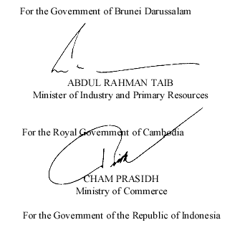 | 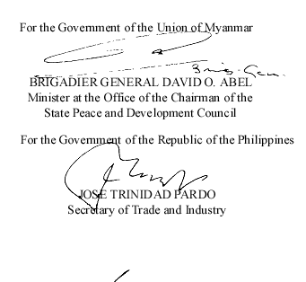
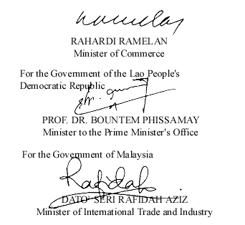 | 